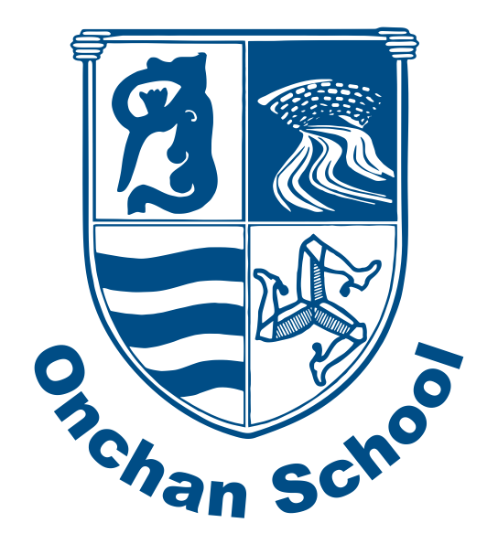
4
Welcome Back!
We hope you had a fantastic Easter break and are ready for our final term of the year!
We are crossing our fingers tightly that the beautiful weather will continue. As we are now in the warmer months, please do ensure that your child has a named water bottle in school each day. Where appropriate, please apply suncream before your child arrives at school in the morning. We are unable to provide or apply this for them.

Mon 4th May – Bank Holiday
Thurs 21st May – KS1 Victorian Day
Fri 22nd May – INSET (School closed to children)
Mon 25th May – TT Break
Mon 8th June – School re-opens for Summer 2
Wed 10th June – Class Photo Day
Thurs 11th June- Sports Day
Fri 3rd July – Transition Day
Tues 7th July – Reports released
Thurs 23rd July- School closes for Summer

_{Summmm}
Key Dates for your Diary
Notes for the Summer Term
Please ensure your child brings their reading book and reading record to school every day. Books are changed once a week, but children may also change them on other days if needed. We encourage you to read a variety of texts at home with your child, alongside their school reading books. A reminder that Phonics Learning Logs should be returned to school each Thursday, please.
We are very much looking forward to celebrating our wonderful school’s 150th Anniversary this term! As you know, we will be marking this in various ways. A big well done to all those who have been stretching their legs and logging their steps, to join us in our ‘150km for 150 years challenge.’ Keep up the hard work and please do send in any photos you have of your accomplishments here! Stay tuned for more information on further celebrations soon
In the classroom, much of our learning will be focused upon both school and life in general throughout the 150 year period. We have begun the explore the ways in which our modern homes differ from those of the Victorian period. We are looking forward to learning all about Victorian toys, travel, communication and technology, before immersing ourselves in Victorian Life for a themed day on Thursday 21st May. More information will follow on this soon. Please do chat to the children about their learning- they will love to share it with you, and perhaps teach you some facts that you didn’t know before!
If you have any queries or need to record absences, please email the school office at onchanEnquiries@sch.im and they will pass on any relevant information. If you require a more in-depth chat, please see your class teacher to arrange an appointment suitable for all.
If you have any questions, please just ask.
Miss Harrison, Mrs Smith, Miss Cubbon, Mrs Watterson and Miss Fargher

Summer Newsletter – Year 1

