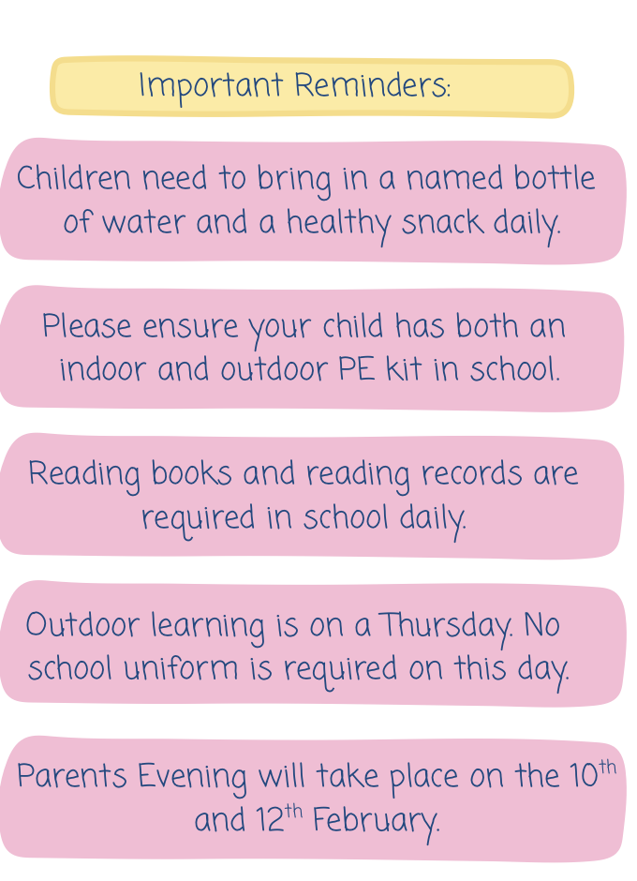
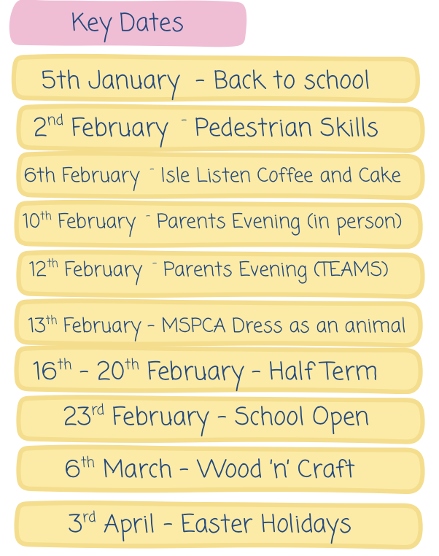


Welcome Back!
Spring Newsletter – Year 1

Welcome back! We hope you all had a lovely Christmas break and a very happy New Year! This term you will notice that Mrs Sullivan, who has been working in Foundation Stage last term, will be supporting us in the Pandas class too. This is a vital part of her teacher training before she goes back into Foundation Stage after Easter. Miss Sullivan will be working with small groups, working across the class when we are teaching and developing some of her teaching skills too. Supporting student teachers is a vital part of what we do, and the children are already loving having an extra adult working with us. You will see her around Year One over the term getting to know how learning develops in our year group.
Parents’ Evening
We are all really looking forward to having you in for parents’ evening at the end of this first half term! This is an opportunity for you as parents to see all the incredible work the children have been working on as well ask any questions you may have. Parents’ evening is on the 10th and 12th February. The 10th is in person for both classes, the 12th is on TEAMs for Bumblebee class and in person for the Pandas. More information regarding times coming soon!

Home Learning
Throughout Autumn Term, we have been working to get TEAMs logins working for our home learning. Thankfully, they are now set up and new logins will be sent home so you can access TEAMs online. On here you will find maths and phonics activities as well links and videos for anyone who would like to complete additional learning at home. We will continue to send home Phonics Logs on a Friday after school with the codes from the week to help the children consolidate their learning at home. We ask that these are returned to school on the following Thursday. Optional tasks are also set on Mathletics which can be completed at home. If you have any issues with your child’s login, please let a member of the Year One team know!

Reading
Please continue to read with your child and to your child at home on a regular basis, using their school reading book as well as other texts you have at home. Please make sure your child brings their reading records and books in to school on a daily basis.
Spring Topics:
Maths: Place Value (within 20, Addition and Subtraction (within 20), Place value (within 50), Length and Height, Mass and Volume.
History: Heroic Women.
Geography: Farming, Agriculture and Machinery.

Home-School Communications
If you have any queries or need to record absences, please email the school office at onchanEnquiries@sch.im and they will pass on any relevant information. If you require a more in-depth chat, please see your class teacher to arrange an appointment suitable for all.
If you have any questions, please just ask.
Miss Harrison, Mrs Smith, Miss Cubbon, Mrs Watterson, Miss Fargher and Mrs Sullivan

