Onchan School SOLE Recording Sheets Name: Date:
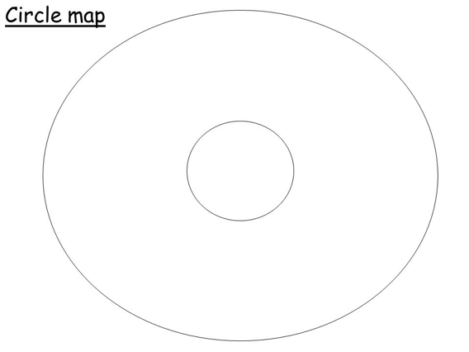

Onchan School SOLE Recording Sheets Name: Date:

List:

Onchan School SOLE Recording Sheets Name: Date:

