Date: WB 11th January 2021
Skill: To use the determiner a or an according to whether the next word begins with a consonant or vowel e.g. a rock, an open box.
Power: Think things through.
Spelling – Write a sentence including each word being used in the correct context (way).
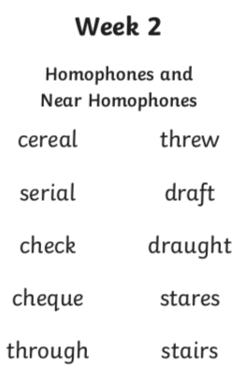
Punctuation and Grammar Practise
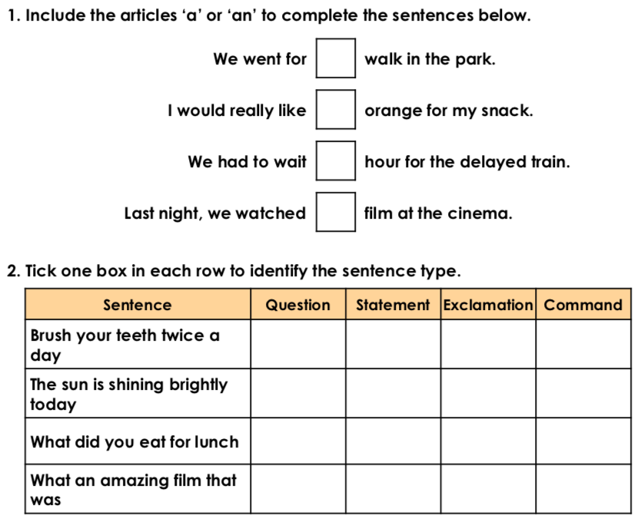
Vocabulary – Dismal
- Find out what dismal means. -

- Put the word dismal into a sentence. –

- Find words that mean the same (synonyms) for dismal. –

