Reading Task – The Day I Fell into a Fairytale (Chapter 9 and 10)
Activity: to define vocabulary, thinking carefully about its meaning and explore characters.

- Read page 114 again. Imagine you are the first fairy and write a reply to the Prince, explaining what has happened.

- Spend some time exploring the sculptures in ‘The Singing Bones’ by Shaun Tan. Choose a favourite fairytale and plan and design a clay sculpture in the style of Shaun Tan, thinking carefully about its shape and form.

- If you have some clay, salt dough or playdough at home maybe you could try to make your sculpture and take a picture to show us.

Hansel and Gretel The Frog Prince

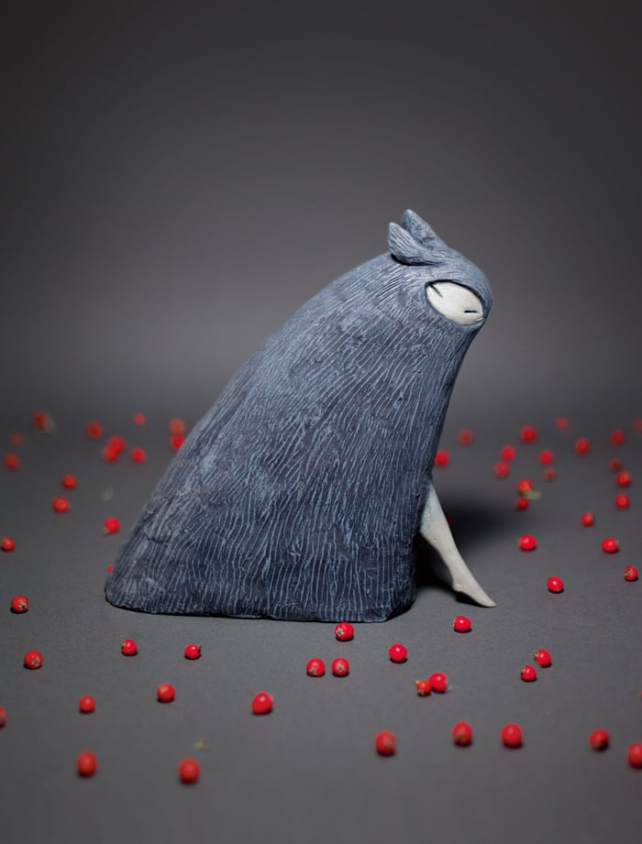
Little Red Riding Hood

