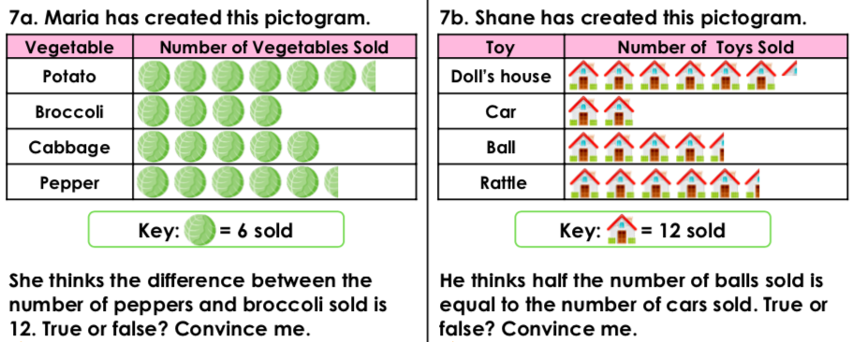

**Working out/Answer**

**1.**

**Working out/Answer**

**2.**



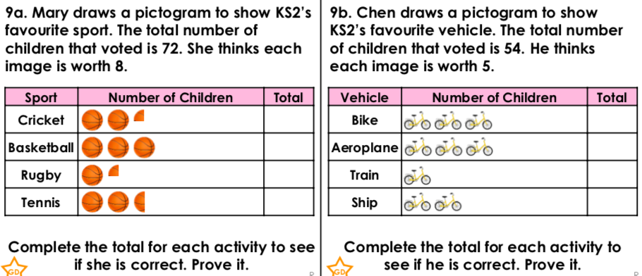

**3.**

**Working out/Answer**



**4.**

**Working out/Answer**