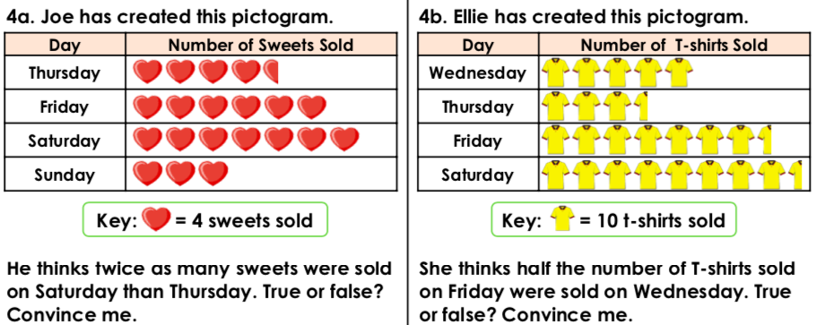

**Working out/Answer**

**1.**



**Working out/Answer**

**2.**

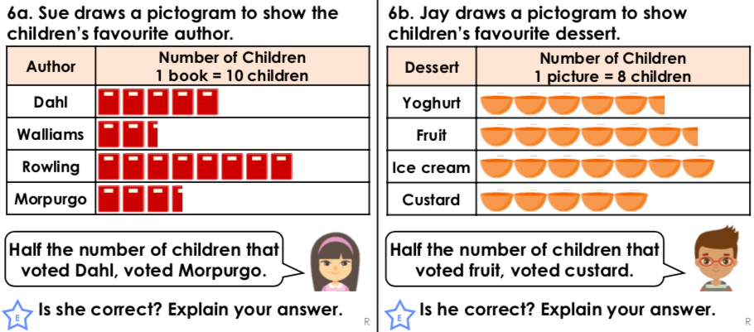

**3.**

**Working out/Answer**



**Working out/Answer**

**4.**