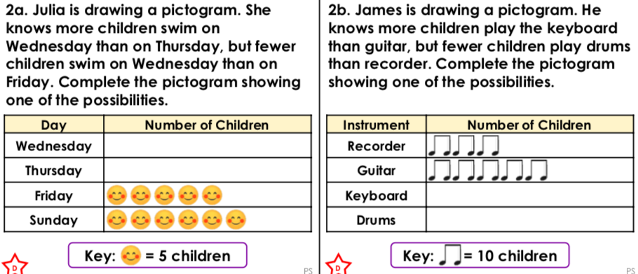

**Working out**

**1.**

**Can you think of two more possibilities and draw the pictograms to show them?**



**Working out**

**2.**

**Can you think of two more possibilities and draw the pictograms to show them?**