Reading Task – The Day I Fell into a Fairytale (Role on the Wall)
Activity: to show your understanding of a character.

This is an outline of Lana from the story. On the inside of her, write down everything you learn about her in the chapters we have read so far. On the outside of her, record any questions you might like to ask her.

Then, in a different colour, imagine you are Lana and answer your questions. How would she respond do you think?
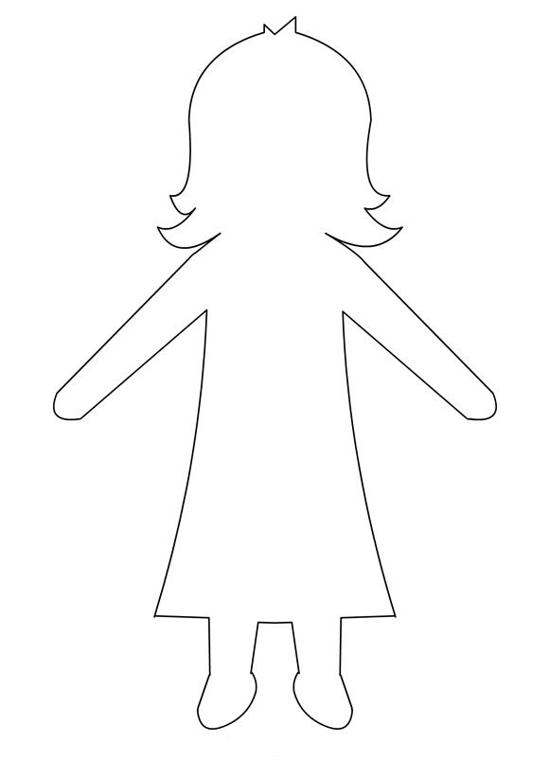
Question…

Question…

Question…

Question…
What have you learnt about Lana so far…?

