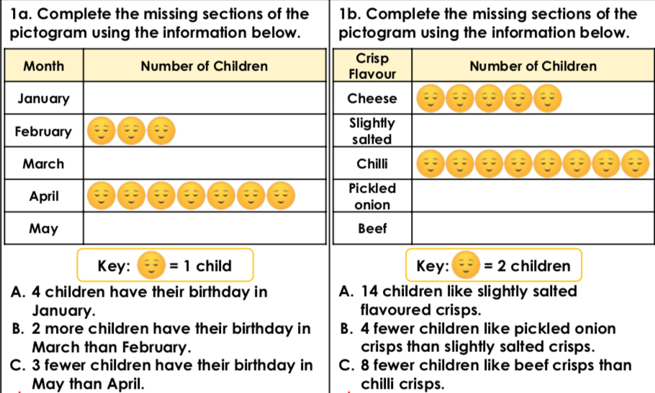

**Working out**

**1.**

**Working out**

**2.**



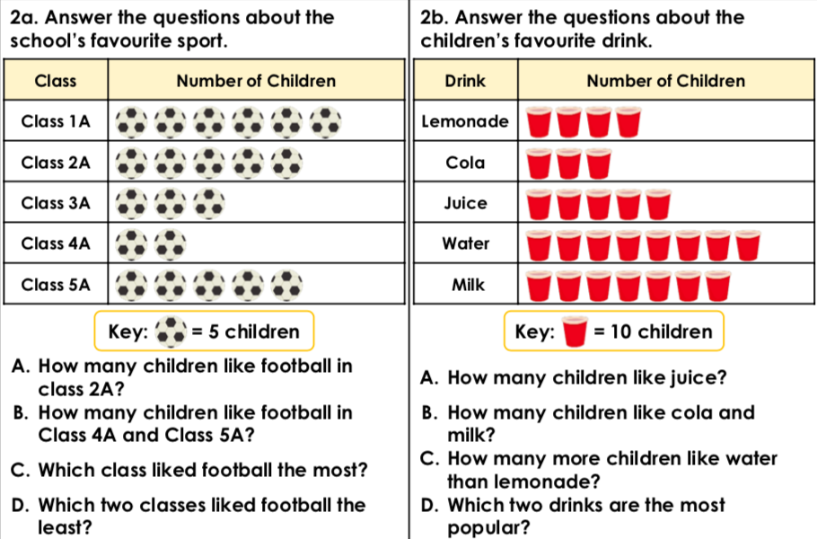

**3.**

**Working out**



**4.**

**Working out**