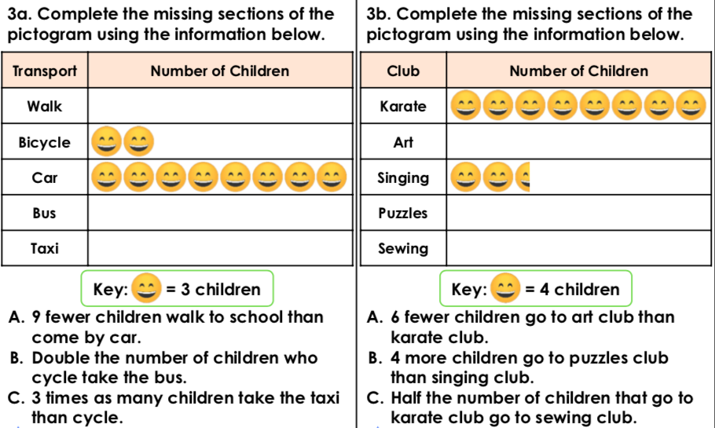

**Working out**

**1.**



**Working out**

**2.**

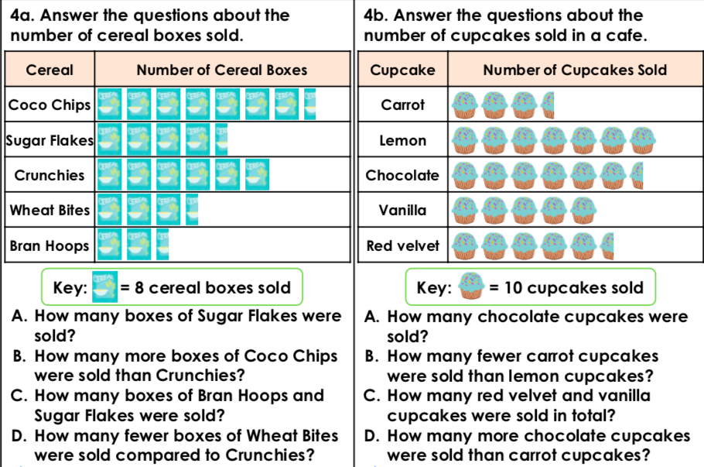

**3.**

**Working out**



**4.**

**Working out**