Literacy - Thursday 7th January
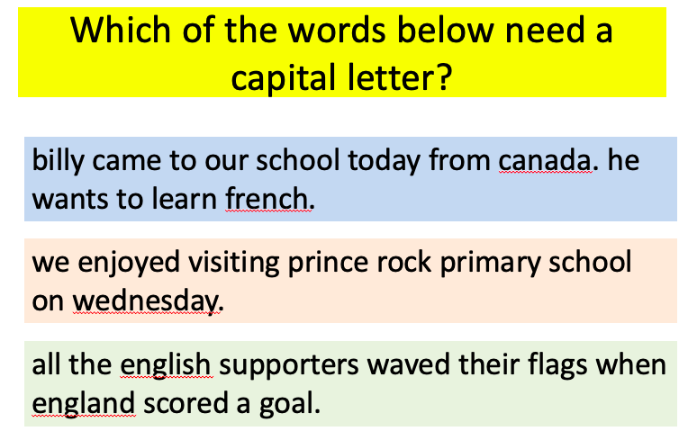
Task one

Task two
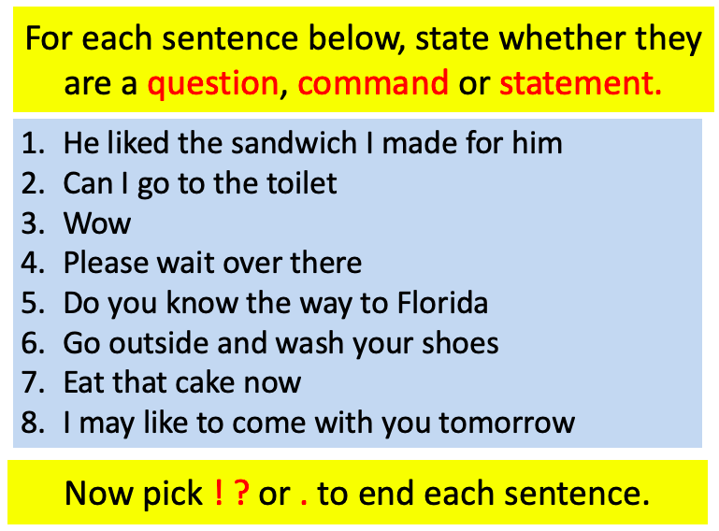

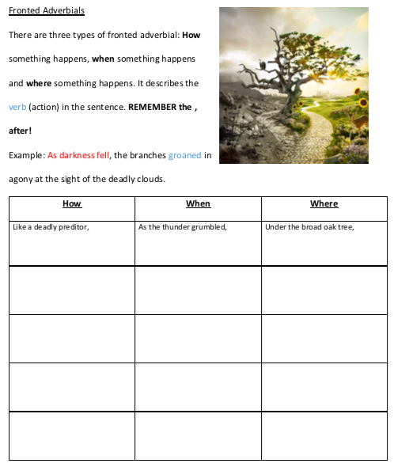
Task three
Like a deadly predator,

- Can you think of some more fronted adverbials to describe this picture and continue the table above?
- Then can you use your fronted adverbials to write a paragraph to describe this picture?

